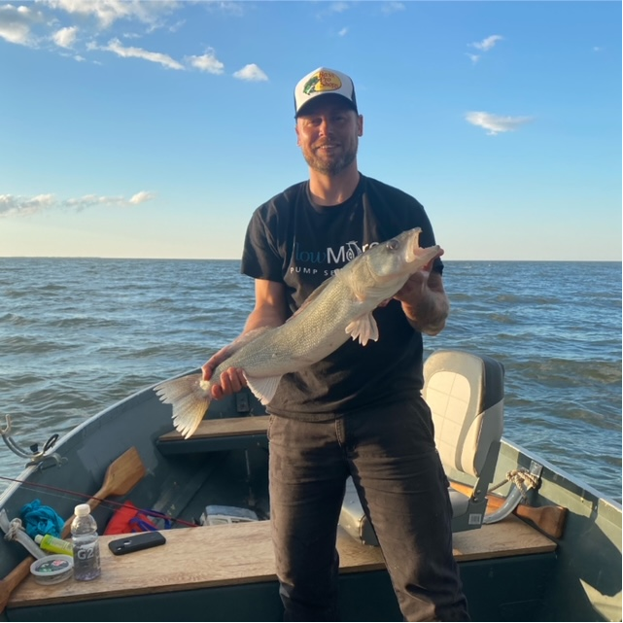
Wpg Beach 26” Walleye

